Operating Systems Project – PHASE 2 Report
Phase 2 — Servers Configuration
Server setup and configuration tasks will be completed in Phase
- Server to configure:
- Web Server (Apache)
INTRODUCTION
A web server is used to host and deliver web pages to users over a network. In this task, an Apache Web Server was installed and configured on an Ubuntu virtual machine. Apache is one of the most widely used open-source web servers. The web server was tested locally and remotely to verify its correct operation.

IMPLEMENTATION
Role Assignment
- Ubuntu 1 → Server OS
- Ubuntu 2 → Client OS
- Web Server Software: Apache2
Step 1 – Updating System Packages
This command updates the package list to ensure the latest versions of software are installed.
sudo apt update
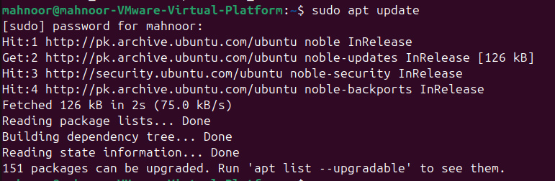
Step 2 – Install Apache Web Server
This command installs the Apache Web Server on Ubuntu. The -y option automatically confirms installation.
sudo apt install apache -y
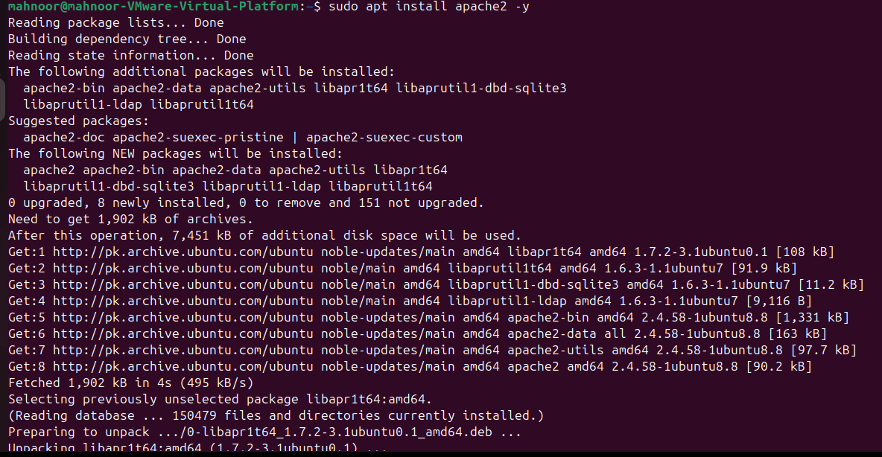
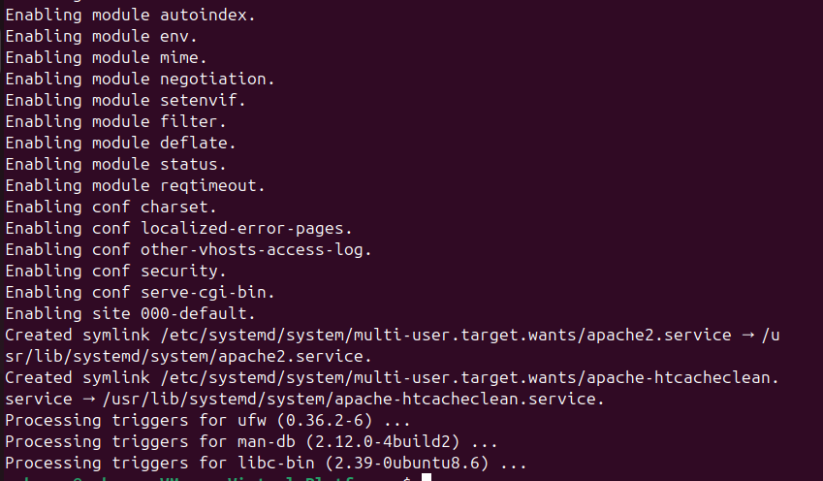
Step 3 – Starting and Enabling Apache Service
sudo systemctl start apache2
sudo systemctl enable apache2
sudo systemctl status apache2
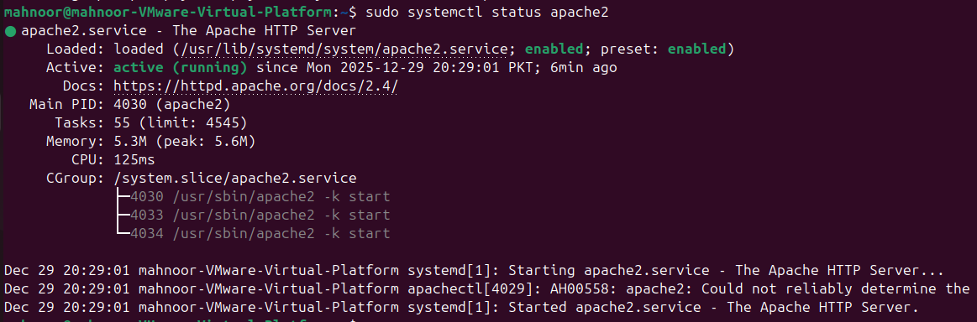
Explanation:
- start → Starts the Apache service immediately
- enable → Allows Apache to start automatically on system boot
- status → Confirms that the Apache service is active and running
Step 4 – Allowing Apache Through Firewall
sudo ufw allow 'Apache'
sudo ufw reload
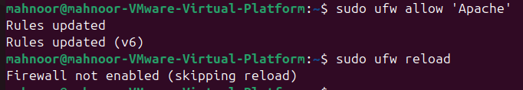
Explanation:
These commands allow HTTP traffic (port 80) so that the web server can be accessed over the network.
Step 5 – Verify Apache Locally
The web server was tested locally by opening a web browser on the server machine and entering:
http://localhost
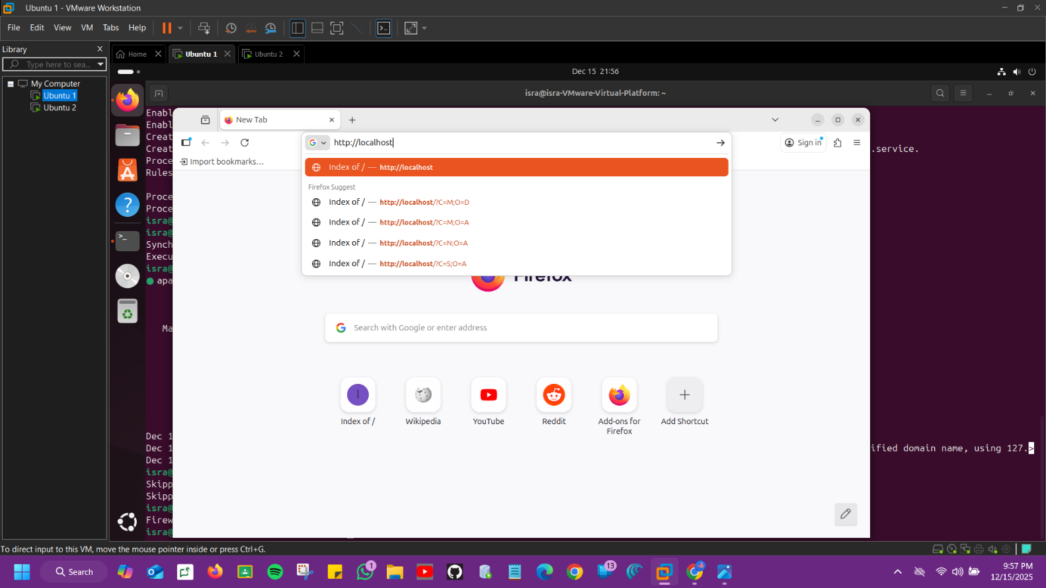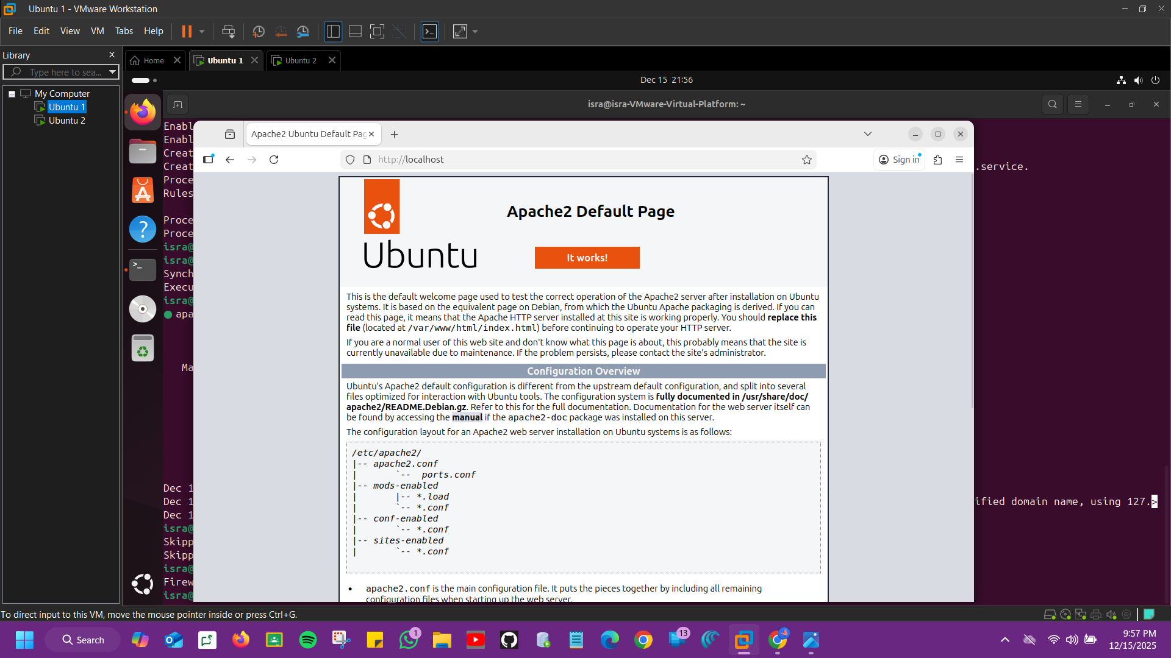
The default Apache2 Ubuntu Default Page appeared, confirming local web server functionality.
Step 6 – Test Web Server Apache from Client Machine (Ubuntu 2)
The IP address of the server machine (Ubuntu 1) was obtained using:
The web server was then accessed from the second Ubuntu virtual machine using:
http://192.168.25.131
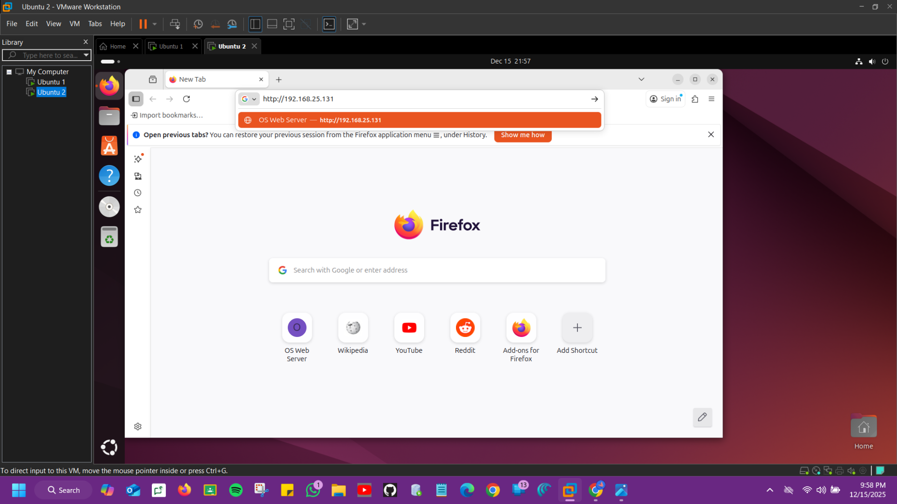
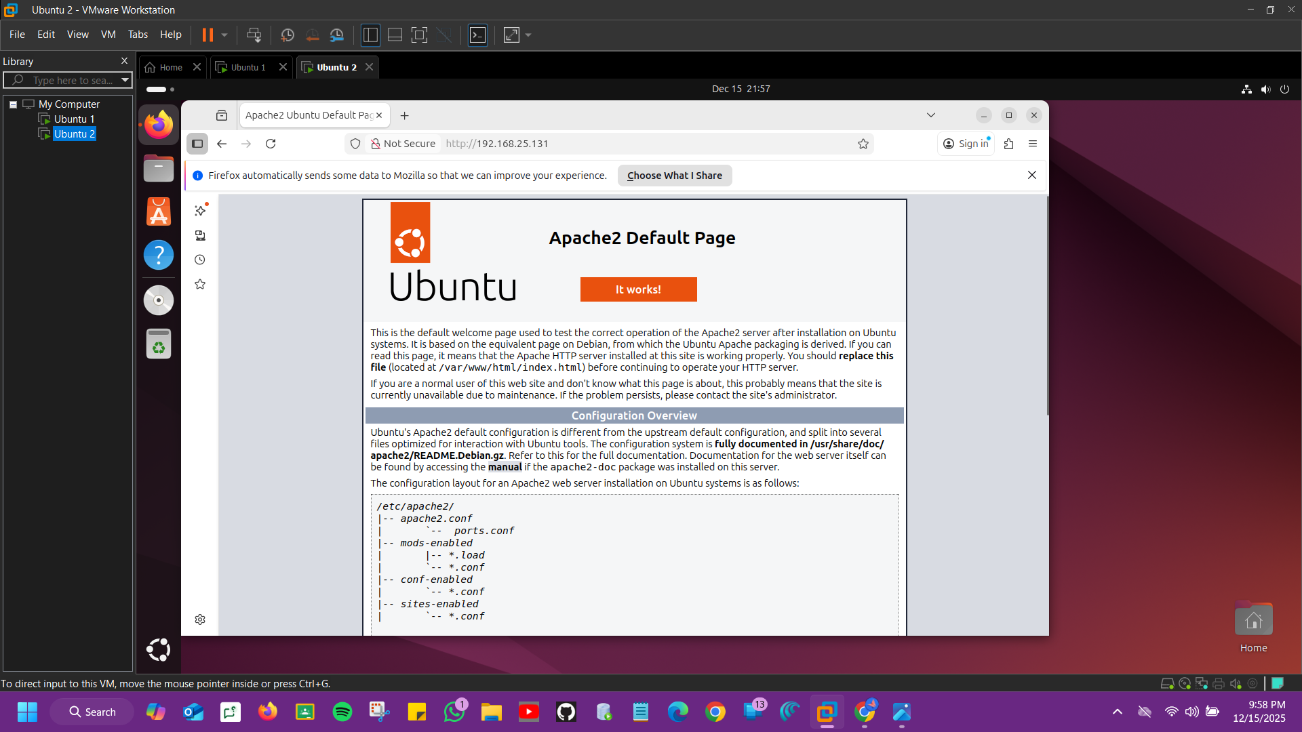
The Apache default page appeared successfully, confirming remote access.
Step 7 – Create a Custom Web Page
On Ubuntu 1:
sudo nano /var/www/html/index.html
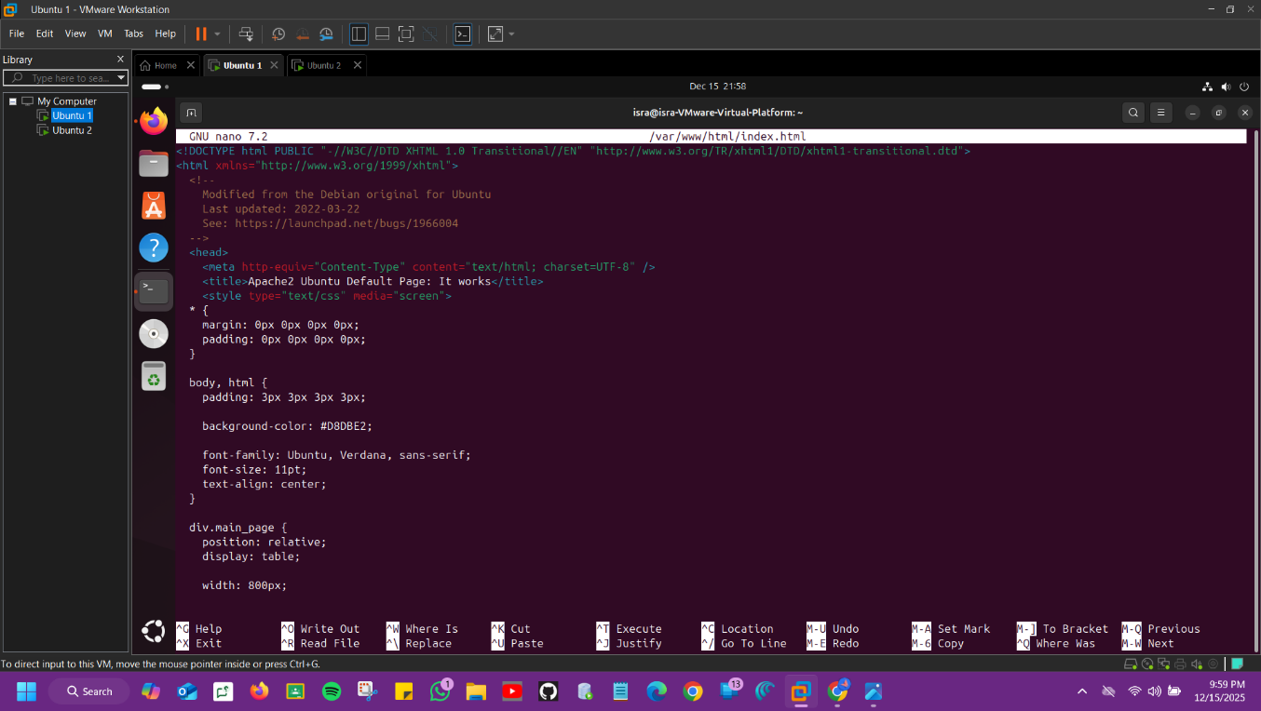
Replace content with:
<html>
<head>
<title>OS Web Server</title>
</head>
<body>
<h1>Apache Web Server is Working</h1>
<p>Phase 2 – Operating Systems Project</p>
</body>
</html>
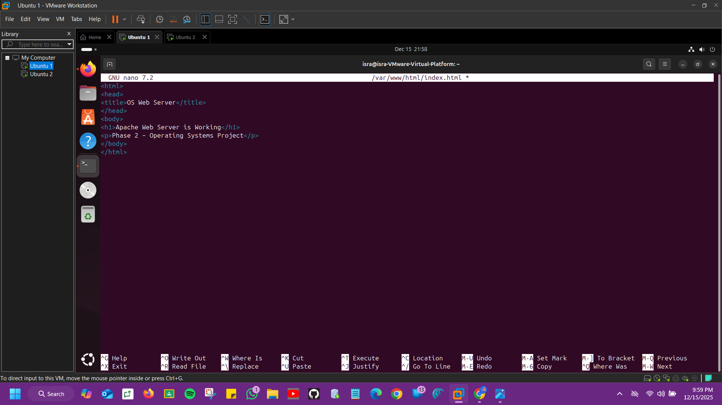
Save and exit.
Note: Refresh browser on Ubuntu 2.
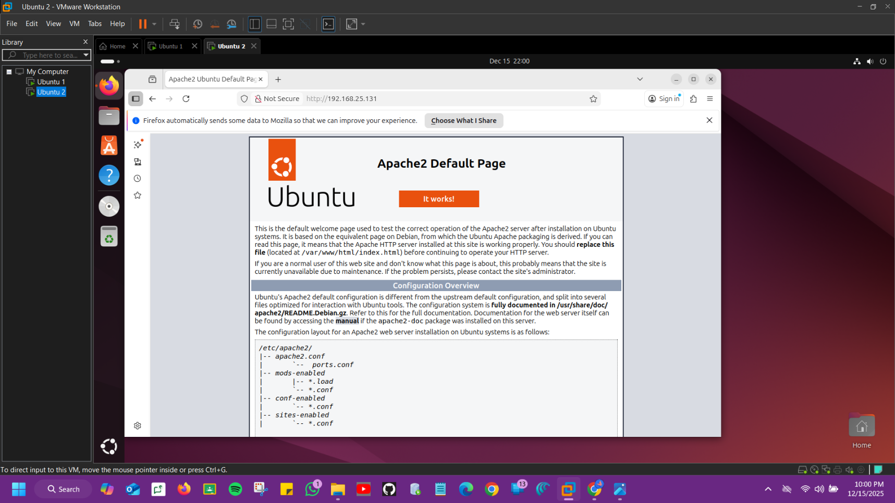
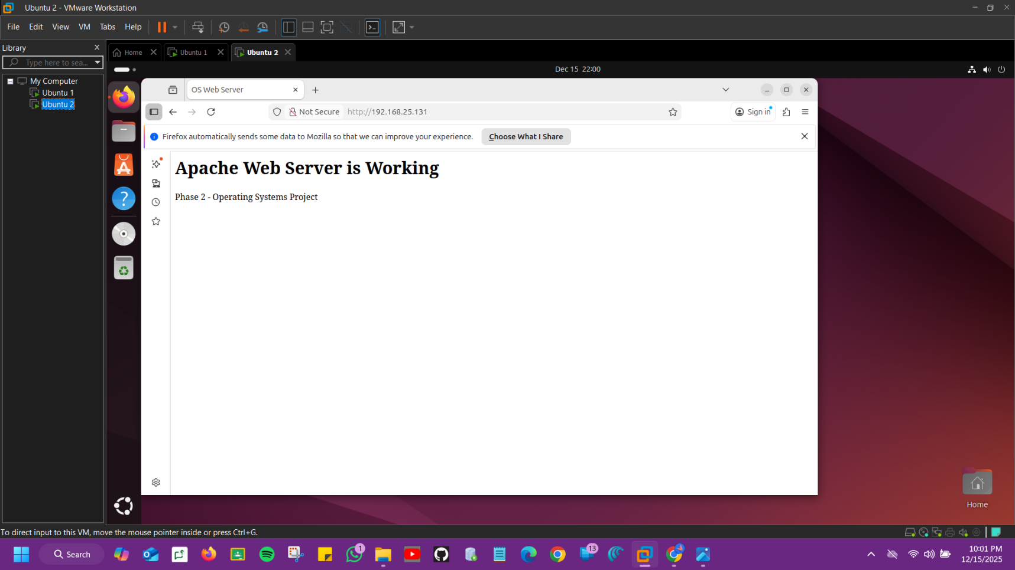

CONCLUSION
In this task, an FTP server was successfully configured using vsftpd on Ubuntu. A client machine connected to the server, authenticated using a local user account, and transferred files successfully. This demonstrates correct server configuration and network communication between the virtual machines.

